Friends of St Cuthbert’s Primary School Hallowe’en Movie Night
Money raised will help fund classroom libraries
please note there will not be a Hallowe’en disco this year

Friday October 18th - 3.10 -5.00

^{st} 3.10 to 5.00

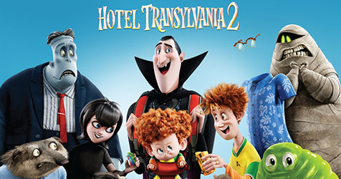
Friday 18th October

Tickets £4.00 per child
(includes drink, popcorn and slice of pizza)

Money must be sent to school in a sealed named envelope marked ‘Movie Night’ containing the exact change and a completed information slip (see below) by Tuesday 15th October. Children will be taken straight from class to the hall at 3.10 and parents can collect them from the front entrance to the school at 5.

____________________________________________________________________

Child’s Name: _______________________________________ Class: ____________

Special Dietary Needs: Please circle Yes No
(if yes please include telephone number so this can be discussed) __________________

Name of person collecting: ____________________________ Tel __________________

